

A Project Report on

**Recommender system for suggesting “Frequently used together” SAP Fiori Apps for SAP S/4 HANA system**

Submitted in partial fulfilment for award of degree of

**PGDBM**

In **Business Analytics**

Submitted by

**Jyoti Singh**

<SRN>

Under the Guidance of

**JB Simha**

<Designation>

REVA Academy for Corporate Excellence

**REVA University**

Rukmini Knowledge Park, Kattigenahalli,

Yelahanka, Bangalore – 560064

**August, 2021**



# Candidate’s Declaration

I, Jyoti Singh hereby declare that I have completed the project work towards the first year of Master of Business Administration in Business Analytics at, REVA University on the topic entitled Recommender system for suggesting “Frequently used together” SAP Fiori Apps for SAP S/4 HANA system under the supervision of <JB Simha and designation>. This report embodies the original work done by me in partial fulfilment of the requirements for the award of degree for the academic year 2021.

Place: Bengaluru Name of the Student: Jyoti Singh

Date: Signature of Student



# Certificate

This is to Certify that the Project work entitled <Title of the Report> carried out by <Student’s Name> with <SRN>, is a bonafide student of REVA University, is submitting the first year project report in fulfilment for the award of <Program Name> in Business Analytics during the academic year <Year>. The Project report has been tested for plagiarism, and has passed the plagiarism test with the similarity score less than 15%. The project report has been approved as it satisfies the academic requirements in respect of PROJECT work prescribed for the said Degree.

Signature of the Guide Signature of the Director

Name of the Guide Name of the Director

Guide Director

External Viva

Names of the Examiners

1. <Name> <Designation> <Signature>
2. <Name> <Designation> <Signature>

Place: Bengaluru

Date:



# Acknowledgement

Please acknowledge the role of your mentors, trainers, classmates, program office members, family and friends who have directly and indirectly supported you in this work.

Please acknowledge the support provided by Hon’ble Chancellor, Dr. P Shayma Raju, Hon’ble Vice Chancellor, Dr. M. Dhanamjaya, and Registrar, Dr. N. Ramesh, as a standard protocol.

Place: Bengaluru

Date:



# Similarity Index Report

This is to certify that this project report titled Recommender system for suggesting “Frequently used together” SAP Fiori Apps for SAP S/4 HANA system was scanned for similarity detection. Process and outcome is given below.

Software Used:

Date of Report Generation:

Similarity Index in %:

Total word count:

Name of the Guide:

Place: Bengaluru Name of the Student:

Date: Signature of Student

Verified by:

Signature

Dr. Shinu Abhi,

Director, Corporate Training

# List of Abbreviations

|  |  |  |
| --- | --- | --- |
| **Sl. No** | **Abbreviation** | **Long Form** |
| 1 | LSTM | Long short-term Memory |
| 2 | GRU | Gated Recurrent Unit |

# List of Figures

|  |  |  |
| --- | --- | --- |
| **No.** | **Name** | **Page No.** |
| Figure No. | Data Architecture for LSTM | 12 |
| Figure No. | CRISP-DM Methodology | 17 |

# List of Tables

|  |  |  |
| --- | --- | --- |
| **No.** | **Name** | **Page No.** |
| Table No. | Precision and Recall of the Model | 9 |
| Table No. | Matrix Predictive Parameters | 10 |

# Abstract

(Not to exceed 1-2 pages)

The Abstract is an important part of the report. It is a succinct summary of the longer report that allows the reader to quickly become familiar with the work described in the report without having to read it all. It briefly advises the reader of the problem, background information include the strategic importance of the problem, concise analysis of the problem, and the primary conclusions and recommendations. Search friendly key words to be mentioned.

**\*CRITICAL:** Do Not Use Symbols, Special Characters, Footnotes, or Math in Paper Title or Abstract.

Keywords: Text Mining, Sentiment Analysis, Natural Language Processing

# Table of Contents

Candidate’s Declaration 2

Certificate 3

Acknowedgement 4

Similarity Index Report 5

List of Abbreviations 6

List of Figures 6

List of Tables 6

Abstract 7

Chapter 1: Introduction 9

Chapter 2: Literature Review 11

Chapter 3: Problem Statement 12

Chapter 4: Objectives of the Study 13

Chapter 5: Project Methodology 14

Chapter 6: Business Understanding 15

Chapter 7: Data Understanding 16

Chapter 8: Data Preparation 17

Chapter 9: Data Modeling 18

Chapter 9: Data Evaluation 19

Chapter 10: Deployment 20

Chapter 11: Analysis and Results 21

Chapter 12: Conclusions and Recommendations for future work 22

Bibliography 23

Appendix 24

Plagiarism Report 25

Publications in a Journal/Conference Presented/White Paper 25

Any Additional Details 26

# Chapter 1: Introduction

(2-3 Pages)

Introduction presents the specific problem under study. It includes general Introduction to the area of your work, current technical advancement in the area, the need of such study, scope of the study etc. State how this study will help organizations/ community. You can use figures, tables and references in the introduction.

* 1. **Background Information**

SAP Business Suite for SAP HANA (S/4 HANA) is SAP's Enterprise Resource planning (ERP) for large enterprises meant to cover all day-to-day processes of an enterprise (for example, order-to-cash, procure-to-pay, plan-to-product, and request-to-service) and core capabilities. It is a next-generation, intelligent ERP business suite and is the successor of SAP ERP designed specifically for SAP’s in-memory computing SAP HANA database.

SAP Fiori is the new User Experience (UX) for SAP software that applies modern design principles. It comprises of the set of apps, that address the most broadly and frequently used SAP functions, such as workflow approvals, information lookups, and self-service tasks etc. They provide simple and easy-to-use user interface across desktops, tablets, and smartphones. SAP Fiori delivers an intuitive, role based UX interface that improves both employee productivity and satisfaction.

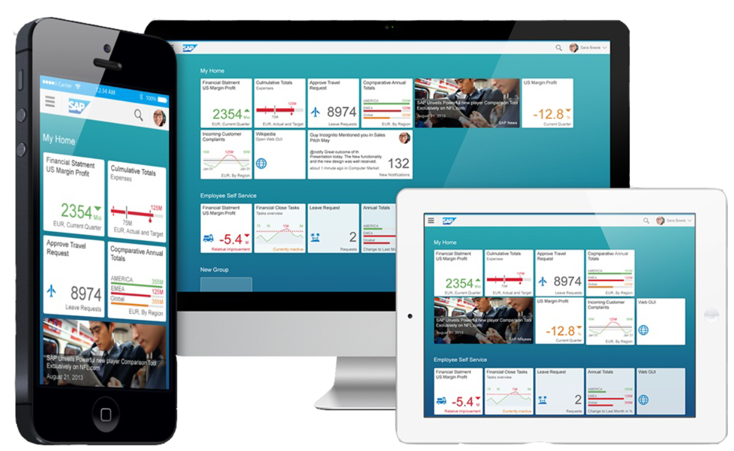

Fig 1.1: SAP Fiori Apps on various platforms

SAP S/4 HANA uses SAP Fiori as its front-end technology to provide personalized, responsive, and simple user experience to customers. All new functions, features and innovations of SAP S/4 HANA are accessible in SAP Fiori Launchpad. Using this launchpad customers can call the backend functionalities for which they have been granted access.

* 1. **Problem Statement**

There are hundreds of SAP Fiori Apps in SAP S/4 HANA system, with simplified user interface supporting multiple device types. However, only few of them are getting actively used by Customers, as many of them are ignorant and unfamiliar with the full library of SAP Fiori Apps.

Customers are unable to use these simplified and the award-winning user interface in the form of Fiori Apps, for most of their day to day activities, resulting in the difficult and slow adoption of S/4 HANA system.

* 1. **Proposed Solution**

Buyers at Amazon know this very prominent offer, after they have picked a product; a bundle of 2-3 products under the title “Frequently bought together” is showcased to buyers. Using this idea, I would like to drive the adoption of SAP Fiori apps among customers, because it is essential for the success of SAP S/4HANA, which is the most widely used product of SAP.

This project will take the usage statistics of SAP Fiori Apps from S/4 HANA on-premise and S/4 HANA Cloud customers. In addition, a mapping will be built for the relationship between Apps based on the Line of Business, Business Role, Industry, Application Area and Customer’s demographic information like Country and Region.

Based on the usage pattern of individual customer, Apps with maximum similarity will be recommended to the customer as ‘Similar Apps’.

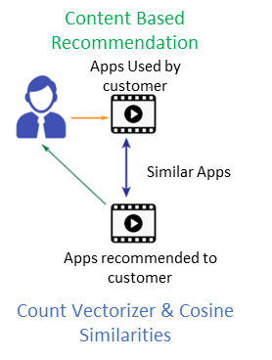

Fig 1.2: Similar Apps

Also, from the combination of the usage data of different customers and the relationship data of Apps and Customers, system will recommend the Best Bets for Apps that a customer is not yet using, but which are trending at other customers who use related apps as ‘Frequently used Apps’.

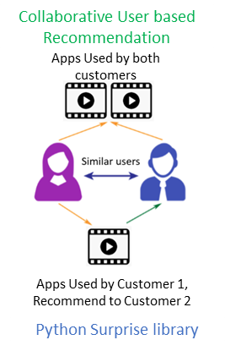

Fig 1.3: Frequently used Apps

In this way a personalized recommendation of trending apps can be provided to the customers and the end-users. This will result in enhanced Customer Satisfaction and in turn better adoption of SAP S/4 HANA system.

# Chapter 2: Literature Review

(2-3 pages)

Review of background theory and existing literature:A Minimum of 15 references from renowned journals/technical reports/websites that must support the problem formulation. A literature review constitutes an essential chapter of a thesis or dissertation, or may be a self-contained review of writings on a subject. In either case, its purpose is to:

* Place each work in the context of its contribution to the understanding of the subject under review
* Describe the relationship of each work to the others under consideration
* Identify new ways to interpret, and shed light on any gaps in, previous research
* Resolve conflicts amongst seemingly contradictory previous studies
* Identify areas of prior scholarship to prevent duplication of effort
* Point the way forward for further research
* Place one's original work in the context of existing literature

Any references taken from websites/journal article/industry whitepapers need to be referenced in text and in the end of the report as Bibliography.

**Sample Only:**

Microblogging websites have evolved to become a source of varied kind of information. This is due to nature of microblogs on which people post real time messages about their opinions on a variety of topics, discuss current issues, complain, and express positive sentiment for products they use in daily life (Srivastava et al., 2019). In fact, companies manufacturing such products have started to poll these microblogs to get a sense of general sentiment for their product. Many times these companies study user reactions and reply to users on microblogs. One challenge is to build technology to detect and summarize an overall sentiment (Prager, 2006).

# Chapter 3: Problem Statement

(1-2 pages)

This section describes the history of the problem as well as its setting. The problem definition shall be described in terms of the internal and external environment where the problem is found; i.e., organization, community, etc. It shall describe groups or organizations affected by the problem (stakeholders), how they are involved, where they are located, and why they have an interest in the problem. The problem definition also describes the organizational structure, function, resources, and processes pertinent to the problem.

A discussion of the history of the problem shall include the extent and longevity of the problem, how it has changed over time, and significant events which have contributed or influenced the problem. This discussion shall also address ramifications of the problem (strategic significance), its symptoms, and why the problem is worthy of study.

# Chapter 4: Objectives of the Study

(1 page)

This section shall clearly describe the purpose of the capstone project and the benefit to be gained; i.e. goals. Goals should be stated in terms of what the student is attempting to discover by conducting the research and clearly describe why this is of strategic/operational importance to the organization/community. This section may require revision as the literature review progresses and understanding of the problem is refined.

# Chapter 5: Project Methodology

(2 pages)

The Methodology section contains a description of the process that will be used to conduct the project. The tools used in the project must be specifically identified and their use must be related to solving the problem that is the focus of the capstone project

Problems faced when implementing the methodology should be discussed in the Capstone Report as well as how they were resolved. This section addresses potential problems and how they will be resolved. If the research methodology/design was changed during the conduct of the project, the changes and the reasons for them should be addressed in this section. The project methodology should be designed to allow conclusions to be drawn about the stated problem.

# Chapter 6: Business Understanding

(2-3 pages)

Articulate the business requirement based on the organizational need. Focus on developing the project objectives and requirements from abusiness perspective, and then converting this knowledge into a data mining problemdefinition, and a preliminary project plan designed to achieve the objectives. You might want to articulate the monetary value in terms of cost benefits and/ or revenue improvement outcomes of embarking such a project.

# Chapter 7: Data Understanding

(4-5 pages)

Clearly write about the data required to develop the solution. You may use an ER diagram to showcase the data and Entity Relationship. You may also list a set of preliminary metrics, KPIs and hypotheses in this section.

# Chapter 8: Data Preparation

(4-5 pages)

This section ideally would cover all the activities needed to construct the final dataset which will be fed into the modelling tools from the initial raw data. Tasks would include table, record, select attributes and transform and clean the data (Extract, Transform, Load (ETL process)). You may recreate a better sample data after editing all the unwanted information. You could present the data patterns and preliminary descriptive analytics. You can also showcase hypothesis testing, correlations and heat maps in this section.

# Chapter 9: Data Modeling

(3-4 pages)

Based on the hypothesis and business objectives set, you need to identify the right modelling techniques and their parameters. You may use a set of predictive, machine learning models. The dataset could be divided into “train and test” to run the models. This section needs to clearly mention the procedure followed in model building.

# Chapter 10: Data Evaluation

(1-2 pages)

Once you built the model(s) you have to thoroughly evaluate and review to make sure that model can achieve the desired business objectives.

# Chapter 11: Deployment

(1-2 pages)

Deployment: Once the model is tested and verified, the live model needs to be applied to the business situation. This phase is critical to actually test the model in real time scenario. Here you may report your results based on the model efficiency.

# Chapter 11: Analysis and Results

(2-3 pages)

The result of project and analysis are presented in this section. This section includes the outcome of the methodology; i.e., the numerical or descriptive work that was performed. For example, if a SWOT analysis is performed, the results are included in this section. Likewise, if a technical analysis is performed, the computational results are included in this section.

# Chapter 12: Conclusions and Future Scope

(1-2 pages)

This is the last section of the text in which conclusions or inferences drawn on the basis of the results of study are described. The conclusions should be linked with the objectives of the study. If possible to express your concluding remarks based on certain numbers, please do so. If you have developed correlations, give such correlations. Recommendations for further research may be included when appropriate. It is important to be careful that the conclusions should not go beyond data and should be based on the study results.

# Bibliography

Prager, J. (2006). Open-domain question-answering. *Foundations and Trends in Information Retrieval*, *1*(2), 91–233. https://doi.org/10.1561/1500000001

Srivastava, A., Singh, V., & Drall, G. S. (2019). Sentiment analysis of twitter data: A hybrid approach. *International Journal of Healthcare Information Systems and Informatics*, *14*(2), 1–16. https://doi.org/10.4018/IJHISI.2019040101

# Appendix

## Plagiarism Report[1]

## Publications in a Journal/Conference Presented/White Paper[2]

## Any Additional Details

1. Turnitn report to be attached from the University.
2. URL of the white paper/Paper published in a Journal/Paper presented in a Conference/Certificates to be provided.